**Chemistry: 13. Ionic and Covalent Bonding**

***Please remember to photocopy 4 pages onto one sheet by going A3→A4 and using back to back on the photocopier***

**Syllabus**

**OC41** Understand how atoms of elements combine to form compounds

**OC42** Recall that ionic bonding is an attraction between positive and negative ions; describe the bonding in NaCl and MgO as examples

**OC43** State what a molecule is, understand that covalent bonds involve the sharing of pairs of electrons, and describe the bonding in H2, O2, H2O, CH4 as examples of covalent bonding

**OC44** Investigate the ability of ionic and covalent substances to conduct electricity

**Student Notes**

**Compounds and Molecules**

Remember our definitions of molecules and compounds from chapter 2: *Elements, Compounds and Mixtures*?

**A molecule is made up of two or more atoms chemically combined.**

**A molecule is the smallest part of an *element* or *compound* that can exist on its own**

**Compounds are substances made from two or more *different* elements *chemically* combined.**

So what does this phrase ‘*chemically combined*’ mean?

First we need to note that there are two ways for atoms to combine chemically, and that another word for the process of combining chemically is ‘*bonding*’.

**Bonding**

**Bonding occurs because all atoms try to have a full outer shell, and will lose, gain or share electrons in order to do so**

There are two separate methods by which atoms join up:

1. Ionic bonding occurs when an atom loses or gains electrons
2. Covalent bonding occurs when an atom shares electrons**.**

**Ionic bonding**

**An ion is a charged atom – i.e. an atom which has lost or gained electrons**

**If an atom loses an electron then it becomes a positive ion.**

**If an atom gains an electron then it becomes a negative ion.**

In ionic bonding positive ions are attracted to negative ions.

**An ionic bond is a bond formed by the force of attraction between two oppositely charged ions**

An example of an ionic bond is sodium chloride

The bonds in sodium chloride are formed by sodium atoms losing electrons and chlorine atoms gaining electrons.

**Examples of ionic bonding: (i) Sodium Chloride (NaCl)**

The atomic number of sodium is 11.

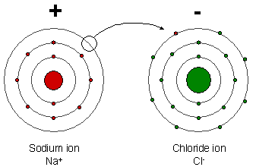It has an electronic configuration of 2, 8, 1. This means that it needs to lose the one electron which it has in its outer shell in order to have a complete outer shell.

The atomic number of chlorine is 17.

Chlorine has an electronic configuration of 2, 8, 7. This means it needs to gain one electron in order to have a complete outer shell.

When a sodium atom bonds with a chlorine atom the sodium atom loses its outer electron to form a positive ion while the chlorine atom gains an electron to form a negative ion.

The two atoms now have opposite charges and because opposite charges attract both atoms move off together as a sodium-chloride (NaCl) molecule.

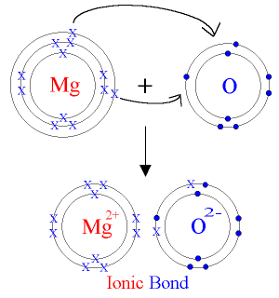***Two atoms walking down the street.***

***First atom: “I think I lost an electron.”***

***Second atom: “Are you sure?”***

***First atom: “Yes, I’m positive”***

**Examples of ionic bonding: (ii) Magnesium Oxide (MgO)**

The atomic number of magnesium is 12.

It has an electronic configuration of 2, 8, 2. This means that it needs to lose the two electrons which it has in its outer shell in order to have a complete outer shell.

The atomic number of oxygen is 8.

Oxygen has an electronic configuration of 2, 6. This means it needs to gain two electrons in order to have a complete outer shell.

When a magnesium atom bonds with an oxygen atom the sodium atom loses its two outer electrons to form a positive ion while the oxygen atom gains two electrons to form a negative ion.

The two atoms now have opposite charges and because opposite charges attract both atoms move off together as a magnesium-oxide (MgO) molecule.

***When I heard that oxygen and magnesium hooked up I was like OMg.***

**Covalent bonding**

**A covalent bond is a bond formed by different atoms sharing electrons in order to have a complete outer shell**

Examples of covalent bonds are H2, O2, H2O and CH4 (methane) molecules.

The bonds in these molecules are formed by the atoms in the molecules sharing electrons with each other..

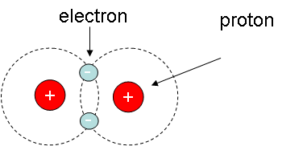

**Examples of covalent bonding: (i) A hydrogen molecule (H2)**

The atomic number of hydrogen is 1.

It needs to have two electrons in its outer shell, and so if it ‘bonds’ with another hydrogen atom and they both ‘share’ their electron with each other, it has the effect of allowing both atoms to have a complete outer shell.

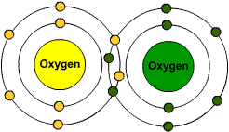

**Examples of covalent bonding: (ii) An oxygen molecule (O2)**

The atomic number of oxygen is 8.

It has an electronic configuration of 2, 6.

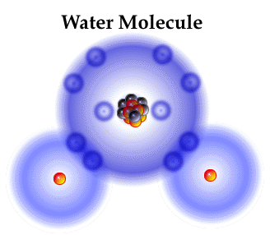It needs to have 8 electrons in its outer shell, and so if it ‘bonds’ with another oxygen atom and they both ‘share’ two of their electrons with each other, it has the effect of allowing both atoms to have a complete outer shell.

**Examples of covalent bonding: (iii) A water molecule (H2O)**

The atomic number of hydrogen is 1 so it has 1 electron in its outer shell.

The atomic number of oxygen is 8 so it has 6 electrons in its outer shell.

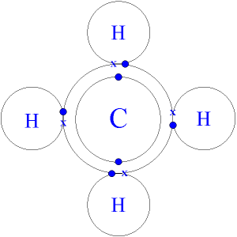Oxygen can share 1 electron with one hydrogen atom and a second electron with a second hydrogen atom, which has the effect of allowing all atoms to have a complete outer shell.

**Examples of covalent bonding: (iv) A methane molecule (CH4)**

The atomic number of hydrogen is 1 so it has 1 electron in its outer shell.

The atomic number of carbon is 6 so it has 4 electrons in its outer shell.

Carbon can share 1 electron with each of 4 different hydrogen atoms, which has the effect of allowing all atoms to have a complete outer shell.

**To investigate the ability of ionic and covalent substances to conduct electricity**

**Procedure**

* Set up a circuit as shown in the diagram.
* Select a number of different substances for testing, e.g. table salt, copper sulphate (both ionic substances), cooking oil and sugar (both covalent substances).
* If the substances are solid then they should be dissolved in pure water before testing.
* If the bulb glows then the substance is a conductor and if it doesn’t glow then it is an insulator.

**Result**

The bulb will only glow for ionic substances.

**Conclusion**

Only ionic substances conduct electricity.

Silly exam question:

Why were the solid substances dissolved in water before the investigation?

**Answer:**

To allow the particles to move

**Properties of Ionic and Covalent compounds**

|  |  |
| --- | --- |
| **Ionic Compounds Examples include table salt and copper sulphate** | **Covalent Compounds Examples include cooking oil and hydrogen gas** |
| Usually solid at room temperature | Usually liquid or gas at room temperature |
| High melting and boiling points | Low melting points |
| Soluble in water | Insoluble in water |
| Conducts electricity | Do not conduct electricity |
| Undergo fast reactions | Undergo slow reactions |

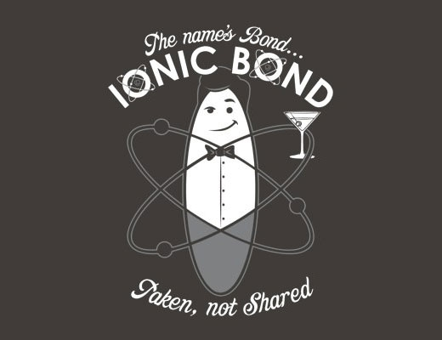

**Exam Questions**

**Ionic Bonding**

1. [2007 OL][2012 OL]

Complete the sentence: In _________ bonding positive ions are attracted to negative ions.

1. [2006 OL]

The bonds in sodium chloride are formed by sodium atoms losing electrons and chlorine atoms gaining electrons.

Name the type of bond found in a sodium-chloride crystal.

1. [2008][2012]

Atoms of different elements can form compounds by bonding together.

What is an ionic bond?

1. [2008]

A pupil investigated the ability of covalent and ionic substances to conduct electricity. Four substances were selected. One was a liquid. The other three substances were solids and these were dissolved in pure water before testing.

The apparatus used in the investigation is drawn below. When the liquids were tested the bulb did not glow in some cases (Liquid type A) and the bulb glowed in other cases (Liquid type B).

The results of the investigation are given in the table.

|  |  |  |  |  |
| --- | --- | --- | --- | --- |
| Liquid | Cooking oil | Table salt | Table sugar | Copper sulphate |
| Liquid type | A | B | A | B |

1. Name the ionic substances in the table. Give a reason for your answer.
2. Three of the substances tested are solid at room temperature. Why were these substances dissolved in water before the investigation?
3. [2009]

The diagram shows sodium ions (+) and chloride ions (-) in part of a crystal of table salt, sodium chloride.

1. How are sodium ions and chloride ions formed from their atoms?
2. What force holds the ions together in sodium chloride?
3. Name one other compound that is composed of ions.

**Covalent Bonding**

1. [20ll OL]2007 OL][2012 OL]

Complete the sentence: In _________ bonding pairs of electrons are shared.

1. [2007]

The diagram shows a molecule of C60. It has 60 carbon atoms covalently bonded together.

This molecule is nick-named the ‘Buckey Ball’.

Explain the underlined term.

1. [2006 OL]

The bond in a molecule of hydrogen gas is formed by a shared pair of electrons.

Name the type of bond found in hydrogen gas.

1. [2008]

Some atoms join together by sharing pairs of electrons.

This is called covalent bonding.

Draw a diagram showing the covalent bonding in a molecule of water.



1. [2011]

The diagram shows the way the atoms bond together in a molecule of water.

1. Each hydrogen atom shares two electrons with the oxygen atom.

What name is given to the type of bonding that involves the sharing of pairs of electrons?

1. Draw a diagram of a methane molecule, CH4, showing the bonding between its atoms.
2. Describe a second type of chemical bonding and name a compound which has this type of bonding.
3. [2009]

The diagram shows a group of water molecules with one enlarged below with its constituent atoms identified by their atomic symbols.

Water molecules are very tiny, one teaspoon of water contains approximately 2 × 1023 molecules.

1. Name the type of bonding in the water molecule.
2. Describe this type of bond.
3. Name one other compound with this type of bonding.

**Exam Solutions**

1. Ionic
2. Ionic
3. It is a bond formed by the force of attraction between two oppositely charged ions.
4. Table salt and copper sulphate are both ionic substances because they both conduct electricity.
5. To allow the particles to move/ the solids would not conduct
6. Sodium ions lose one electron to leave it with a full outer shell and chlorine ions gain one electron to form a full outer shell.
7. Electrical
8. Magnesium oxide/ magnesium chloride/ calcium oxide/ calcium chloride/ potassium iodide...
9. Covalent
10. Covalently bonded means that the electrons are shared between different atoms.
11. Covalent
12. See diagram
13. Covalent
14. See diagram
15. A second type of bonding is called ionic bonding; this occurs when atoms join together by losing or gaining electrons to form positive or negative ions.

e.g. sodium chloride

1. Covalent
2. Electrons are shared between the different atoms so that all atoms have a complete outer shell.
3. Carbon dioxide/ ammonia/ glucose/ methane...

**Other Test Questions**

1. Name one property of ionic and one property of covalent compounds:
2. Draw a diagram (using suitable circuit symbols) of the circuit needed to investigate the ability of ionic and covalent compounds to conduct electricity.
3. How could you tell whether a compound was ionic or covalent?
4. Draw a diagram showing the ionic bonding in the compound magnesium oxide.
5. Draw a diagram showing the bonding in a water molecule.
6. Draw a labelled diagram to show the type of bonding in an oxygen molecule.
7. Name the type of bonding present in a crystal of sodium chloride.

Give one property of this type of bonding:

1. In a negatively charged ion the number of is greater than the number of .
2. In a positively charged ion the number of is greater than the number of .
3. List two properties of an ionic substance.
4. List two properties of compounds which are formed by sharing electrons.
5. Underline the two elements in the list below that normally exist as molecules:

Hydrogen Chlorine Helium Aluminium Gold.

**For teachers**

Students’ misconceptions about covalent bonding include the following:

•covalent bonding involves the sharing of a single electron

•the number of covalent bonds is equal to the number of electrons in the outer shell

•electrons are always shared equally in a covalent bond

•covalent bonds are broken when a covalent substance melts or boils

In ionic bonding common misconceptions are:

•the use of the term molecule in describing ionic substances

•the defining of ionic bonding as the transfer of electrons

•thinking in terms of ion-pairs

•difficulties in understanding the three dimensional nature of ionic bonding

Further information about these and other student misconceptions in chemistry can be found in the article and books listed below.

Beyond appearances: *“Students’ misconceptions about basic chemical ideas”,* by Vanessa Barker. Royal Society of Chemistry

Website: **http://www.chemsoc.org/pdf/LearnNet/rsc/miscon.pdf**

*“Chemical misconceptions – prevention, diagnosis and cure”,* by Keith Taber

Volume 1: Theoretical background

Volume 2: Classroom resources

published by the Royal Society of Chemistry

Website: **http://www.chemsoc.org/pdf/LearnNet**